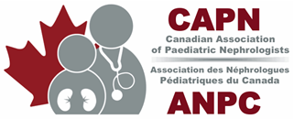
ADVOCACY PROPOSAL TEMPLATE
CAPN has the mandate to represent Canadian pediatric nephrologists and advocate for our patients and their families. In order to accomplish our mandate, we would like to solicit ideas for advocacy issues important for our members.
Maximum 2 pages
ADVOCACY Proposal:
What is the issue?
Who does it affect?
What are the implications of the proposed change or status quo?
What stories do you have to illustrate this issue (patient stories, personal stories) and its impact?
Proposal:
Why? (Please detail why you think CAPN should advocate for your issue, relevance, importance, etc.)
How? (Which method should be employed to advocate for this issue)
Opinion editorial? Where?
Published scientific guidelines or consensus “white paper”? Where?
Media release for television / radio?
Social media?
Meetings with law makers or policy makers (note local, provincial or federal). Who?
List the stakeholders (stratify by local, provincial or federal influence)?
Who does this affect (patient groups? Students? Physicians? Population at large?)
Who has the leverage to change policy or legislation (hospital admin? Provincial jurisdiction?
Federal jurisdiction? Media contacts?)
Who are the allies who would be interested in joining this discussion? (other physician groups?
Allied health)

CAPN members name:

Contact info : email:

Please return the completed form to contact@capneph.ca

